The Future of Computer-Assisted Education
- what it is & How does it work?
- Differences Between Education 1.0 to 4.0
2- The rise of online education
3- Smart CLasses
5- Advantage and Disadvantage
6- Findings
7- Analysis

“Education is the passport to the future, for tomorrow belongs to those who prepare for it today.” – Malcolm X.
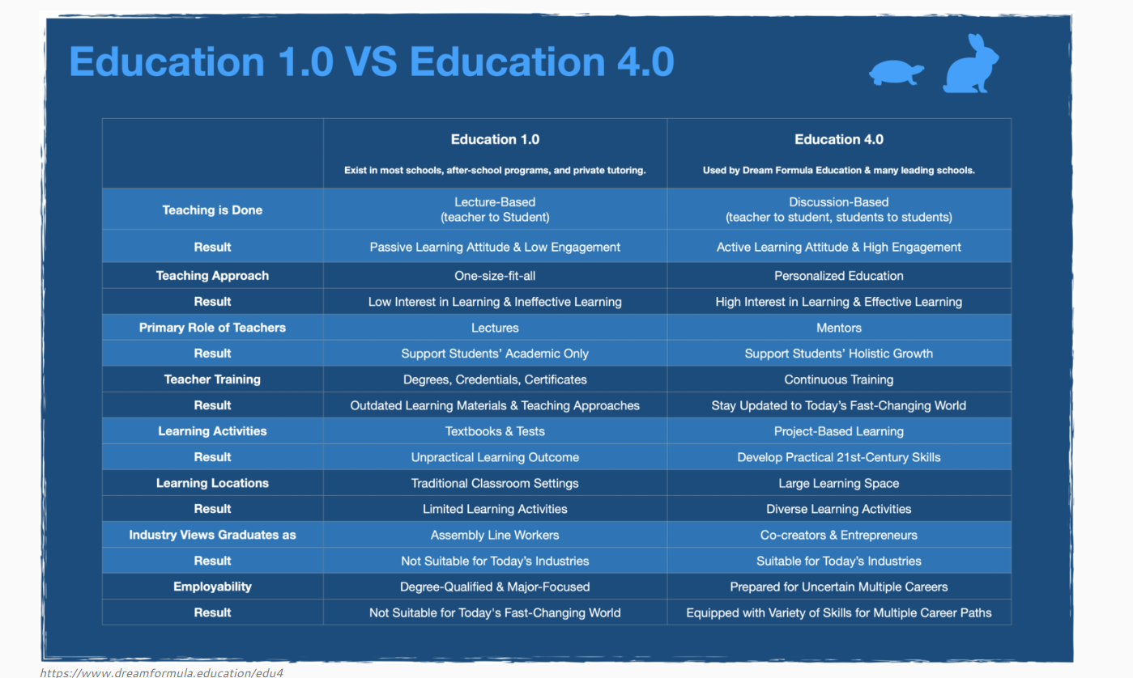
Education 1.0:
- Technology was forbidden in Classroom.
- Teacher-centered system – the teacher gives knowledge as the absolute leader in the classroom.
Education 2.0:
- The technology is free and/or easily accessible, increased use of virtual reality
- Learning is done at home or outside school, while in school students develop skills.
- The teacher is transformed into a coordinator/facilitator, advisor, learner and practice guide.

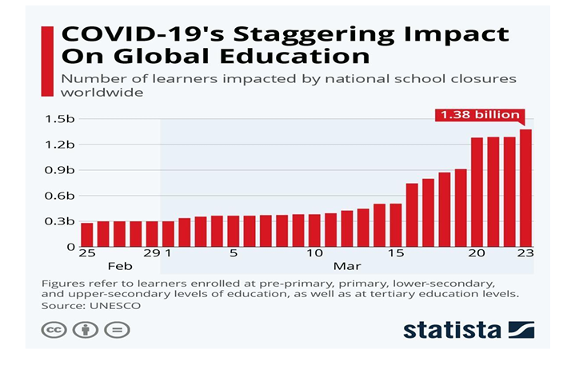

We can enumerable advantages of computer assisted education. Some of them are- • Simplified and interactive way of attaining knowledge • Motivates student to learn • Makes training process simplified • Combines text, audios, videos in an appealing way • Assists teacher in teaching process • Develops student’s intelligence

For instance, in today’s are of pandemic where whole world is locked down, it is very important to note that student’s education is not a full stop. Many computer applications like- ZOOM, MICROSOFT TEAMS etc are there assisting the education sector of schools and universities. They have not substituted any teacher rather have enabled a platform where teachers can virtually create a live classroom with all the students live at one place and teach them. They offer many features like- screen sharing, raising hand etc for better and enhanced version of teaching.
EXAMPLES:
This pandemic started from China and the lockdown was first observed there. Amidst lockdown, education should not suffer. Chinese government used Ten cent classrooms which made availability of education online. This is observed as the “largest online movement” in history of education where in approximately 7, 30,000 students took online classes in Wuhan.
Many countries developed their own online education platform. Singapore developed “Lark” as their portal. Byju Raveendran, the founder of Byju’s announced t give a free access to its learning app. After this announcement, the company has experienced a 60% surge in users having access to attractive and interactive videos.

